EXPERIMENT:1 Write the python program to Solve 8-Puzzle problem
Aim
To write and execute a Python program to solve the 8-Puzzle problem using the Breadth-First Search (BFS) algorithm.
Objective
To move the tiles of an 8-puzzle from the initial state to the goal state by moving the blank space (0).
Algorithm
- Start with the initial puzzle configuration.
- Represent the blank space by 0.
- Define the goal state as:
- 1 2 3
- 4 5 6
7 8 0
- Add the initial state to a queue.
- Remove a state from the front of the queue.
- Find the position of the blank tile.
- Generate all possible moves by moving the blank tile up, down, left, or right.
- Add unvisited states to the queue.
- Continue until the goal state is reached.
- Display all steps from the initial state to the goal state.
Python Program
from collections import deque
# Goal state
GOAL = (1, 2, 3,
4, 5, 6,
7, 8, 0)
# Possible movements of blank space
MOVES = {
0: [1, 3],
1: [0, 2, 4],
2: [1, 5],
3: [0, 4, 6],
4: [1, 3, 5, 7],
5: [2, 4, 8],
6: [3, 7],
7: [4, 6, 8],
8: [5, 7]
}
# Display puzzle
def display(state):
for i in range(0, 9, 3):
print(state[i:i+3])
print()
# BFS algorithm
def solve_puzzle(start):
queue = deque()
queue.append((start, [start]))
visited = set()
visited.add(start)
while queue:
current, path = queue.popleft()
# Check goal
if current == GOAL:
return path
# Find blank position
blank = current.index(0)
# Generate next states
for position in MOVES[blank]:
new_state = list(current)
# Swap blank and tile
new_state[blank], new_state[position] = \
new_state[position], new_state[blank]
new_state = tuple(new_state)
# Visit only new states
if new_state not in visited:
visited.add(new_state)
queue.append(
(new_state, path + [new_state])
)
return None
# Initial state
start = (1, 2, 3,
4, 0, 6,
7, 5, 8)
# Solve puzzle
solution = solve_puzzle(start)
# Display result
if solution:
print("Solution Found!")
print("Number of moves:", len(solution) - 1)
print("\nSteps:")
for i, state in enumerate(solution):
print("Step", i)
display(state)
else:
print("No solution exists.")
Sample Input
1 2 3
4 0 6
7 5 8
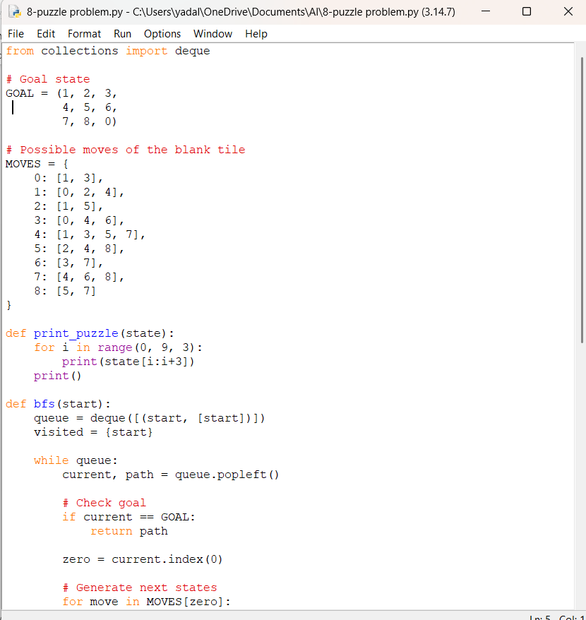
Output
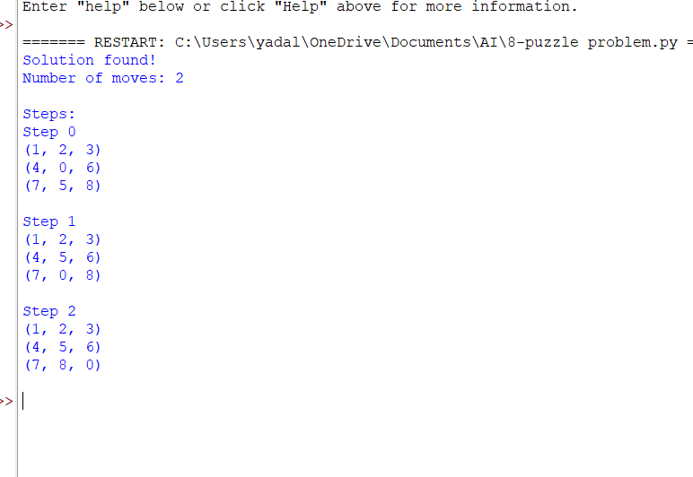Result
Thus, the 8-Puzzle problem was successfully solved using the Breadth-First Search algorithm, and the initial state was transformed into the required goal state.

